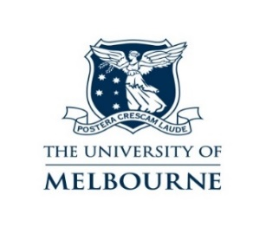
The University of Melbourne Chaplaincy and Religions for Peace Victoria invite you to a FREE lecture:
Tuesday 6th February 2018 - 5.30-7.30pm
Appraising the Royal Commission Report into Sexual Abuse and Religious Organizations
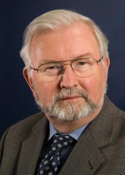 | By Emeritus Professor Desmond Cahill OAM  B.A., S.T.L., M.Ed., Ph.D, F.A.C.E.L.  Chair: Religions for Peace Australia http://religionsforpeaceaustralia.org.au  Educated in Australia and Italy, Desmond Cahill, Professor of Intercultural Studies at RMIT University, is one of Australia's leading social researchers. In 2006, he was made an honorary fellow of the Australian Council of Educational Leaders for his work in immigrant, cross-cultural, interfaith and international education. He currently chairs the Religions for Peace (Australia), and represents Australia on the Asian Conference of Religion and Peace (ACRP). He led Melbourne's successful bid to stage the 2009 Parliament of the World's Religions, the world's largest interfaith gathering, and is now its Melbourne Program Director. A member of the Australian Partnership of Religious Organizations (APRO) and of the Victoria Police Multifaith Advisory Council, he is a Club Melbourne Ambassador as part of the “Think Melbourne, Think Victoria” strategy of the Victorian Government. He was consultant to the Royal Commission on Sexual Abuse and Religious Organizations from 2015-2017.

Laby Theatre (L108) in the Physics Building Melbourne University located near Melbourne Uni’s tram stop on Swanston Street https://maps.unimelb.edu.au/parkville/building/192s/laby_theatre
RSVP: Try Booking web address
https://www.trybooking.com/book/search?keyword=Un%20interfaith%20harmony
Or Sue Ennis: wcrpaust@iinet.net.au / Sunny Chen: sunnyc1@unimelb.edu.au

